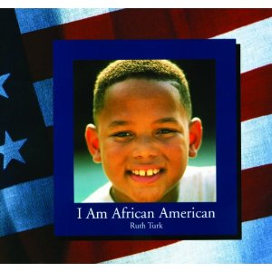
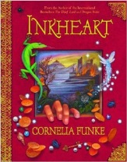
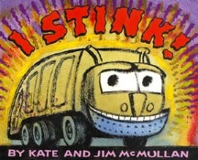
Reading Counts quiz titles. Blue titles are series books.
Call #: FIC = Fiction. E = Everybody (picture books) # = Nonfiction L = Language
I | AUTHOR | CALL # | READING LEVEL | POINTS
I Am African American | Turk, Ruth | 305.8 TUR | 3.8 | 2
I Am Chinese American | Lee, Amy | 305.8 LEE | 3.8 | 2
I Am Indian American | Stuart, Jane | 305.8 STU | 3.8 | 2
I Am Irish American | Connor, Ellwood | 305.8 CON | 3.8 | 2
I Am Italian American | DePalma, Brenda | 305.8 DEP | 3.8 | 2
I Am Japanese American | Emery, Vivian | 305.8 EME | 3.8 | 2
I Am Jewish American | Weitzman, Eliz | 305.8 WEI | 3.8 | 2
I Am Korean American | Kim, Robert | 305.8 KIM | 3.8 | 2
I Am Mexican American | Seymour, Isobel | 305.8 SEY | 3.8 | 2
I Am Native American | Sage, Ana | 305.8 SAG | 3.8 | 2
I Am Polish American | Kapowski, Sam | 305.8 KAP | 3.8 | 2
I Am Vietnamese American | Blanc, Felice | 305.8 BLA | 3.9 | 2
I Am Not Going to Get Up Today | Dr. Seuss | E SEU | 2.3 | 1
I Can Lick 30 Tigers Today | Dr. Seuss | E SEU | 3.3 | 2
I Can Read with My Eyes Shut | Dr. Seuss | E SEU | 2.4 | 1
I Don’t Want to Take a Bath! | Sykes, Julie | E SYK | 2.8 | 2
I Had Trouble in Solla Sollew | Seuss, Dr. | E SEU | 3.7 | 2
I Hate English! | Levine, Ellen | E LEV | 1.8 | 2
I Have a Dream (anthology) | King, Jr. Dr Mar | 921 KIN | 6.9 | 2
I Live in Your Basement (GooseBumps) | Stine, R.L. | FIC STI | 4.2 | 6
I, Q Book 1: Independence Hall | Smith, Roland | FIC SMI | 3.5 | 15
I Pledge Allegiance | Swanson, June | 323.6 SWA | 2.5 | 2
I Stink! | McMullan, Kate | 629.224 MCM | 1.7 | 1
I thought my soul would rise fly | Hansen, Joyce | FIC HAN | 4.8 | 7
I Wanna Iguana (CYRM) | Orloff, Karen K | E ORL | 2.3 | 1
I want a pony (Pony Pals) | Betancourt | FIC BET | 3.9 | 4
I Will Never – Eat A Tomato | Child, Lauren | E CHI | 2.8 | 1
I’m Terrific | Sharmat, M | E SHA | 3.3 | 2
I, Crocodile | Marcellino, F | E MAR | 1.7 | 2
I, Doko: The Tale of a Basket (CYRM) | Young, Ed | E YOU | 3.5 | 1
Icky Bug Alphabet Book, The | Pallotta, Jerry | E PAL | 4.9 | 2
Ida B…and Her Plans to Maximize (CYRM) | Hannigan, K | FIC HAN | 6.4 | 9
If a Bus Could Talk | Ringgold, F | 921 PAR | 5.1 | 2
If I Ran the Zoo | Dr. Seuss | E SEU | 3.8 | 2
If You Give a Moose a Muffin | Numeroff, Laura | E NUM | 2.7 | 1
If You Give a Mouse a Cookie | Numeroff, Laura | E NUM | 1.8 | 1
If You Give a Pig a Pancake | Numeroff, Laura | E.NUM | 2.8 | 1
If You Give a Pig a Party | Numeroff, Laura | E.NUM | 2.5 | 1
If You Made a Million | Schwartz, David | 332.024 SCH | 3.9 | 2
If You Sailed on the Mayflower in 1620 | McGovern, Ann | 973.2 MCG | 3.9 | 3
If You Take A Mouse To School | Numeroff, Laura | E NUM | 2.3 | 1
If You Were There… Signed the Constitution | Levy, Elizabeth | 342.73 LEV | 5.2 | 3
Iggie’s House | Blume, Judy | FIC BLU | 4.3 | 7
Illinois – America the Beautiful | Santella, Andrew | 977.3 SAN | 9.0 | 6
Immigrant Kids | Freedman, Russell | 301.43 FRE | 7.5 | 3
Imogene’s Antlers | Small, David | E SMA | 3.5 | 1
In a People House | LeSieg, Theo | E LES | 2.5 | 1
In the Night Kitchen | Sendak, Maurice | E SEN | 2.8 | 1
In the Small, Small Pond | Fleming, Denise | E FLE | 2.5 | 1
In The Time of the Drums | Siegeson, Kim | FIC SIE | 3.5 | 3
In the Year of the Boar and Jackie Robinson | Lord, Bette Bao | FIC LOR | 3.8 | 6
Incident at Hawk’s Hill | Eckert, Allan W. | FIC ECK | 6.6 | 14
Incredible Journey, The | Burnford, Sheila | FIC BUR | 8.1 | 8
Indian Captive | Lenski, Lois | FIC LEN | 5.7 | 15
Indian in the Cupboard | Banks, Lynne | FIC BAN | 5.9 | 9
Indian Winter | Freedman, R | 917.804 FRE | 6.5 | 5
Inkheart | Funke, Cornelia | FIC FUN | 4.9 | 29
Inkspell | Funke, Cornelia | FIC FUN | 5.6 | 37
Inspector Hopper | Cusman, Doug | E CUS | 2.32
Interrupted Journey | Lasky, Kathryn | FIC LAS | 4.6 | 3
Into the A,B, Sea | Rose, Deborah | 591.77 ROS | 2.7 | 1
Into the Land of the Lost (Droon) | Abbott, Tony | FIC ABB | 3.4 | 4
Into The Wild (Warriors) | Hunter Erin | FIC HUN | 5.2 | 15
Invasion, The (Animorphs) | Applegate, K.A. | FIC APP | 5.1 | 10
Ireland (Postcards From) | Arnold, Helen | 941.5 ARN | 2.7 | 2
Iron Dragon Never Sleeps | Krensky, Stephen | FIC KRE | 2.7 | 3
Ironwood Tree | Black, Holly | FIC BLA | 4.1 | 4
Is a Dolphin a Fish? | Berger, M |  | 4.6 | 3
Is Your Mama a Llama? | Guarino, D | Audio E GUA | 1.6 | 1
Ish | Reynolds, Peter | E REY | 2.1 | 1
Island of the Aunts | Ibbotson, Eva | FIC IBB | 5.7 | 14
Island of the Blue Dolphins | O’Dell, Scott | FIC ODE | 5.5 | 12
Isle of the Dead (Dragons of Deltora) | Rodda, Emily | FIC ROD | 4.3 | 10
Israel (post cards from) | Allard, Denise | 956.94 ALL
It Could Always Be Worse | Zemach, Margot | 398.2 ZEM | 4.5 | 2
It's All Greek to Me | Scieszka, Jon | FIC SCI | 4.1 | 4
It’s Like This, Cat | Neville, Emily | FIC NEV | 6.1 | 7
It's Mine | Lionni, Leo | E LIO | 2.9 | 1
It's Raining Benjamins | Gregory, D | FIC GRE | 4.9 | 8
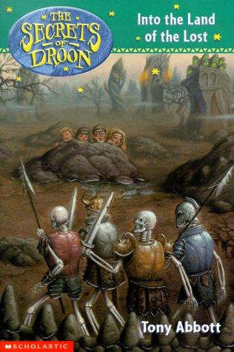  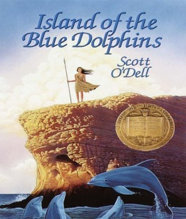  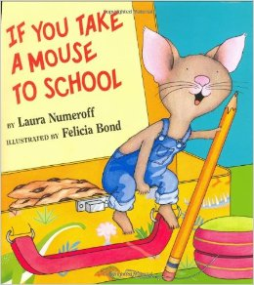  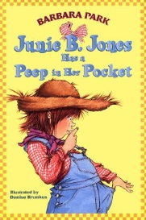  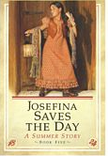  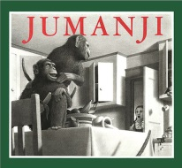  J | 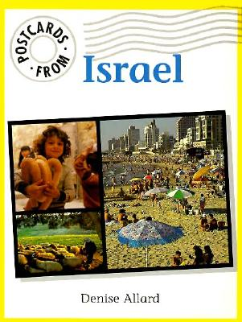  Author | 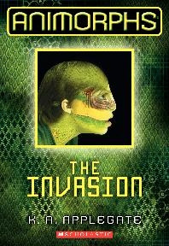  Call # | 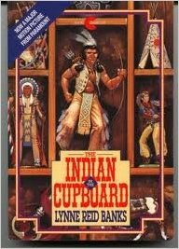  RL | Pts
Jacob Have I Loved | Paterson, K | FIC PAT | 5.8 | 11
Jahanara, Princess of... India (1627) | Lasky K | FIC LAS | 5.8 | 8
Jamaica Tag-Along | Havill, J | E HAV | 2.1 | 2
Jamaica's Find | Havill, Juanita | E HAV | 3.7 | 2
Jamberry | Degen, B | E DEG | 2.5 | 1
James and the Giant Peach | Dahl, Roald | FIC DAH | 6.7 | 8
Jane on Her Own: A Catwings Tale | Le Guin, Ursula | FIC LEG | 4.8 | 3
Janet’s Thingamajigs | Cleary, Beverly | E CLE | 3.5 | 2
Janitor's Boy, the | Clements, A | FIC CLE | 4.3 | 8
Japan (Postcards From) | Dawson, Zoe | 952 DAW | 2.7 | 2
Jason's Gold | Hobbs, Will | FIC HOB | 5.9 | 11
Jazz Man | Weik, Mary Hays | FIC WEI | 4.5 | 3
Jellyfish | Landau, Elaine | 593.5 LAN | 5.5 | 3
Jennifer, Hecate, Macbeth, William ... and me | Konigsburg, E.L. | FIC KON | 4.9 | 5
Jessica | Henkes, Kevin | E HEN | 1.9 | 1
Jessie De La Cruz: Profile | Soto, Gary | 921 DEL | 6.7 | 9
Jimmy's Boa Bounces Back | Noble, T | E NOB | 3.5 | 1
Jip, His Story | Paterson, K | FIC PAT | 5.5 | 10
Joey Pigza Loses control | Gantos, J | FIC GAN | 5.2 | 11
Joey Pigza Swallowed the Key | Gantos, J | FIC GAN | 5.2 | 9
Johnny Hangtime | Gutman, Dan | FIC GUT | 5.3 | 10
Johnny Tremain | Forbes, Esther | FIC FOR | 5.3 | 19
Jonathan Cleaned Up | Munsch, Robert | E MUN | 3.7 | 2
Josefina Story Quilt, The | Coerr, Eleanor | E COE | 3.5 | 2
Josefina Saves the Day (American Girls) | Tripp, Valerie | FIC TRI | 4.7 | 3
Josefina's Surprise (American Girls) | Tripp, Valerie | FIC TRI | 5.5 | 3
Joseph Had a Little Overcoat | Taback, Simms | E TAB | 1.9 | 1
Journal of Ben Uchida.... (Dear America) | Benenberg, B | FIC DEN | 5.6 | 6
Journal of Douglas Allen.... (Dear Ameri) | Philbrick, R | FIC PHI | 5.7 | 9
Journal of Finn Reardon, News (Dear Amer) | Bartoletti, S | FIC BAR | 5.3 | 9
Journal of James Edmond P.... (Dear America) | Murphy, Jim | FIC MUR | 6.8 | 10
Journal of Jasper Jonathan... (Dear America) | Rinaldi, Ann | FIC RIN | 6.5 | 9
Journal of Jedediah Barstow... (Dear Amer) | Levine, Ellen | FIC LEV | 5.5 | 9
Journal of Joshua Loper.... (Dear America) | Myers, Walter D | FIC MYE | 5.9 | 8
Journal of Rufus Rowe.... (Dear America) | Hite, Sid | FIC HIT | 5.8 | 7
Journal of Sean Sullivan.... (Dear America) | Durbin, W | FIC DUR | 5.7 | 7
Journal of William T. Emerson.... (Dear Amer) | Denenberg, B | FIC DEN | 4.8 | 6
Journey (Guardians Of Ga'Hoole) | Lasky, Kathryn | FIC LAS | 4.5 | 11
Journey of a Turtle, The | Scrace, C | 597.92 SCR | 2.7 | 1
Journey to the New World (Dear Amer) | Lasky, Kathryn | FIC LAS | 6.5 | 7
Journey to the Center of the Earth | Verne, Jules | FIC VER | 7.9 | 16
Journey to the Volcano Palace (Droon) | Abbot, Tony | FIC ABB | 3.1 | 4
Joyful Noise: Poems for Two Voices | Fleischman, Paul | 811.54 FLE | 5.2 | 2
Juan Bobo Goes to Work | Montes, Marisa | 398.2 MON | 2.8 | 2
Judy Moody: Around the World | McDonald, M | E MCD | 3.3 | 5
Judy Moody Gets Famous | McDonald, M | E MCD | 3.2 | 4
Judy Moody, M. D. | McDonald, M | E MCD | 3.3 | 5
Judy Moody Declares Independence | McDonald, M | E MCD | 3.2 | 5
Julie | George, Jean | FIC GEO | 5.6 | 11
Julie of the Wolves | George , Jean | FIC GEO | 5.6 | 8
Julius, The Baby of the World | Henkes, Kevin | E HEN | 2.9 | 2
Jumanji | Van Allsburg, C | FIC VAN | 4.4 | 5
Jumanji (Espanol) | Van Allsburg, C | FIC VAN | 2.7 | 5
Junebug | Mead, Alice | FiC MEA | 5.5 | 6
Junie B. Jones/Sneaky, peeky spying | Parker, Barbara | FIC PAR | 2.1 | 3
Junie B. Jones/Is Not a Crook | Parker, Barbara | FIC PAR | 2.1 | 3
Junie B. Jones/First Grader: Aloha | Parker, Barbara | FIC PAR | 1.9 | 5
Junie B. Jones/First Grader (at Last) | Parker, Barbara | FIC PAR | 2.5 | 3
Junie B. Jones/First Grader: Boo | Parker, Barbara | FIC PAR | 2.5 | 4
Junie B. Jones/First Grader: Boss of L | Parker, Barbara | FIC PAR | 2.5 | 3
Junie B. Jones/First Grader: Cheater P | Parker, Barbara | FIC PAR | 2.5 | 3
Junie B. Jones: Jingle Bells | Parker, Barbara | FIC PAR | 2.5 | 5
Junie B. Jones/First Grader: one-man | Parker, Barbara | FIC PAR | 2.6 | 3
Junie B. Jones/First Grader: Tooth | Parker, Barbara | FIC PAR | 2.5 | 3
Junie B. Jones/Shipwrecked | Parker, Barbara | FIC PAR | 2.5 | 3
Junie B. Jones/Monkey Business | Parker, Barbara | FIC PAR | 1.9 | 3
Junie B. Jones/Big Fat Mouth | Parker, Barbara | FIC PAR | 2.1 | 3
Junie B. Jones/That Meanie Jim | Parker, Barbara | FIC PAR | 2.1 | 3
Junie B. Jones/Mushy Gushy Valentine | Parker, Barbara | FIC PAR | 2.1 | 4
Junie B. Jones/Stupid Smelly Bus | Parker, Barbara | FIC PAR | 2.1 | 3
Junie B. Jones/Yucky Blucky Fruitcake | Parker, Barbara | FIC PAR | 2.1 | 3
Junie B. Jones/Monster Under Bed | Parker, Barbara | FIC PAR | 1.8 | 3
Junie B. Jones/Peep in Her Pocket | Parker, Barbara | FIC PAR | 2.1 | 4
Junie B. Jones/(Almost) Flower Girl | Parker, Barbara | FIC PAR | 2.3 | 3
Junie B. Jones/Beauty Shop Guy | Parker, Barbara | FIC PAR | 2.1 | 3
Junie B. Jones/Graduation Girl | Parker, Barbara | FIC PAR | 2.2 | 3
Junie B. Jones/Party Animal | Parker, Barbara | FIC PAR | 2.3 | 3
Junie B. Jones/Captain Field Day | Parker, Barbara | FIC PAR | 2.1 | 4
Junie B. Jones/Loves handsome Warren | Parker, Barbara | FIC PAR | 2.1 | 3
Junie B. Jones/Smells Something Fishy | Parker, Barbara | FIC PAR | 1.8 | 3
Jupiter (Galaxy) | Vogt, Gregory |  | 2.5 | 3
Just Me and My Mom | Mayer, Mercer | PB M | 1.9 | 1
Just Plain Fancy | Polacco, Patricia | E POL | 3.8 | 2
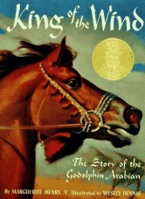  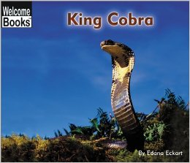  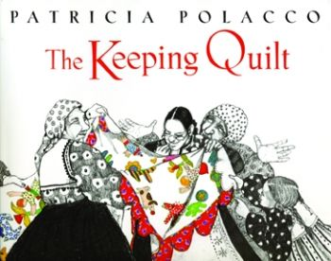  K | Author | Call # | Reading Level | Points
Kansas – America the Beautiful | Robinson, Nancy | 978.1 ROB | 9.0 | 6
Kate and the Beanstalk | Osborne, Mary |  | 3.5 | 2
Keepers | Watts, Jeri Hanel | E WAT | 4.8 | 2
Keeping Quilt, The | Polacco, Patricia | E POL | 5.3 | 2
Kensuke's Kingdom | Morpurgo, M | FIC MOR | 4.8 | 8
Kentucky – America the Beautiful | Stein, R. Conrad | 976.9 STE | 9.0 | 6
Kenya (Postcards From) | Arnold, Helen | 967.62 ARN | 2.2 | 2
Key to the Indian (Indian in the Cupbrd) | Banks, L. R. | FIC BAN | 6.1 | 14
Kid in The Red Jacket, The | Park, Barbara | FIC PAR | 4.5 | 5
Kid Who Ran for President, The | Gutman, Dan | FIC GUT | 5.4 | 5
Kids During the Great Depression | Wroble, L | 973.91 WRO | 4.3 | 2
Killer Whales | Simon, Seymour | 599.5 SEY | 2.7 | 1
King Bidgood’s in the Bathtub | Wood, Audrey | E WOO | 2.1 | 1
King Cobra | Eckart, Edana | 597.96 ECK | 1.8 | 1
King of the Wind | Henry, Marguerit | FIC HEN | 6.1 | 7
King’s Stilts, The | Seuss, Dr. | E SEU | 4.6 | 3
King’s Swift Rider | Hunter, Mollie | FIC HUN | 7.5 | 9
Kirsten and the New Girl (Amer. Girls) | Shaw, Janet | FIC TRI | 4.5 | 3
Kirsten on the Trail (Amer. Girls) | Shaw, Janet | FIC TRI | 4.5 | 3
Kiss for Little Bear, A | Minarik, E. H. | E MIN | 2.3 | 1
Kissing Hand, The | Penn, Audrey | E PEN | 3.3 | 1
Kit Learns a Lesson (Amer. Girls) | Tripp, Valerie | FIC TRI | 4.2 | 3
Kit, Adventures of a Raccoon | Woods, Shirley | FIC WOO | 4.1 | 5
Kite Fighters, The | Park, Linda Sue | FIC PAR | 6.3 | 8
Kitten’s First Full Moon | Henkes, Kevin | E HEN | 1.7 | 1
Kneeknock Rise | Babbbitt, Natalie | FIC BAB | 4.3 | 4
Knight at Dawn, The (Magic Tree House) | Osborne, Mary P. | FIC OSB | 2.5 | 3
Knights Don’t Teach Piano (Bailey Sch) | Dadey, Debbie | FIC DAD | 3.5 | 3
Koko’s Kitten | Patterson, Dr. F | 599.88 | 4.6 | 3
Korea (1999) (True Book) | Landau, Elaine | 951.9 LAN | 4.9 | 3
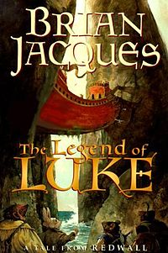  Korean Cinderella, The | Climo, Shirley | 398.2 CLI | 4.5 | 2
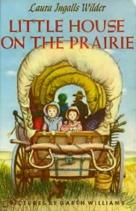  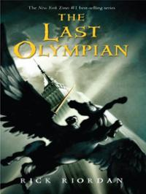  Kringle | Abbott, Tony | FIC ABB | 4.8 | 15
L | Author | Call # | Reading Level | Points
Lady Lollipop | King-Smith, Dick | FIC KIN | 4.8 | 4
Lamb in the Laundry (Animal Ark) | Baglio, Ben | FIC BAG | 4.1 | 7
Land I Lost, The | Huynh, Q Nhuon | 959.7 NHU | 6.9 | 7
Land of the Buffalo Bones | Bauer, Marion | FIC BAU | 4.9 | 10
Landed | Lee, Milly | E LEE | 4.4 | 3
Last Battle, The (Narnia) | Lewis, C.S. | FIC LEW | 5.8 | 9
Last Holiday Concert, The | Clements, A. | FIC CLE | 4.2 | 6
Last of the Really Great Wangdoodles | Edwards, Julie | FIC EDW | 7.3 | 13
Last of the Breed | Steele, Alexander | FIC STE | 5.1 | 9
Last Olympian (Percy Jackson) | Riordan, Rick | FIC RIO | 3.5 | 21
Latkes and Applesauce | Manushkin, F. | FIC MAN | 4.5 | 2
Leah's Pony | Friedrich, E. | E FRI | 2.8 | 2
Legend of Freedom Hill, The | Altman, Linda | E ALT | 3.8 | 3
Legend of Luke, The (Redwall) | Jacques, Brian | FIC JAC | 6.8 | 22
Lemonade for Sale | Murphy, Stuart | 001.4 MUR | 2.5 | 1
Lemonade Trick, The | Corbett, Scott | FIC COR | 4.5 | 4
Leo the Late Bloomer | Kraus, Robert | FRED KIT | 1.7 | 1
Leo the Magnificent | Martin, Ann M. | E MAR | 2.8 | 2
Leprechaun’s Gold, The | Edwards, P | 398.2 EDW | 3.8 | 2
Leprechauns Don’t Play Basketball (Bailey) | Dadey, Debbie | FIC DAD | 4.3 | 3
Let’s Get a Pup! Said Kate | Graham, Bob | E GRA | 2.6 | 2
Let’s Get Invisible (GooseBumps) | Stine, R.L. | FIC STI | 4.5 | 7
Let's Go Froggy! (Froggy) | London, J. | E LON | 1.7 | 1
Let's Jump Rope | Hughes, Sarah | 796.2 HUG | 1.6 | 1
Let’s Play Hide-and-Seek | Hughes, Sarah | 796.1 HUG | 1.2 | 1
Let’s Play Hopscotch | Hughes, Sarah | 796.2 HUG | 1.2 | 1
Let’s Play Tag | Hughes, Sarah | 796 HUG | 1.3 | 1
Let’s Play Tug-of-War | Hughes, Sarah | 796.2 HUG | 1.3 | 1
Let’s Talk About Being Afraid | Kreiner, Anna | 155.4 KRE | 3.4 | 2
Letters are Lost, The | Ernst, Lisa | E ERN | 1.5 | 1
Letters from Camp | Klise, Kate | FIC KLI | 6.7 | 6
Letters from Rifka | Hesse, Karen | FIC HES | 5.1 | 6
Liang and the Magic Paintbrush | Demi | 398.2 DEM | 3.1 | 2
Liberty Bell: Freedom | Wilson, Jon | 973 BEL | 4.2 | 2
Librarian of Basra | Winter, Jeanette | 020 WIN | 3.4 | 1
Librarian - Black Lagoon | Thaler, Mike | E THA | 3.9 | 1
Library Card, The | Spinelli, Jerry | FIC SPI | 5.8 | 8
libro ilustrado sober Abrah | Adler, David A. |  | 3.8 | 2
Life on the Ranch | Kalman, Bobbie | 978 KAL | 3.5 | 3
Light in the Attic, A | Silverstein, Shel | 811 SIL |  | 3
Light in the Storm | Hesse, Karen | FIC HES | 5.6 | 7
Lighthouse Mystery, The (Boxcar) | Warner, G. | FIC WAR | 3.2 | 6
Lightning Thief, The (Percy Jackson) | Riordan, Rick | FIC RIO | 4.7 | 19
Like Jake and Me | Jukes, Mavis | FIC JUK | 5.2 | 3
Lilly's Purple Plastic Purse | Henkes, Kevin | E HEN | 3.5 | 2
Lily’s Crossing | Giff, Patricia | FIC GIF | 5.8 | 7
Line in the Sand, A | Garland, Sherry | FIC GAR | 4.8 | 9
Lion and the Mouse, The | Watts, B. | E WAT | 2.9 | 1
Lion, the Witch & the Wardrobe (Narnia) | Lewis, C.S. | FIC LEW | 6.1 | 9
Little Bat | Cox, Tania | 591.03 COX | 1.6 | 1
Little Bear | Minarik, Else | E MIN | 1.8 | 2
Little Bear's Friend | Minarik, Else | E MIN | 2.1 | 2
Little Engine that Could, The | Piper, Watty | E PIP | 3.9 | 2
Little Gold Star - Cinderella | San Souci, R. | 398.2 SAN | 3.1 | 2
Little House in the Big Woods | Wilder, Laura | FIC WIL | 4.2 | 8
Little House on the Prairie | Wilder, Laura | FIC WIL | 4.3 | 12
Little House, The | Burton, Virginia | E BUR | 3.8 | 2
Little Island | MacDonald, Gold | E MAC | 3.5 | 2
Little Miss Spider/Sunny Patch | Kirk, David | E KIR | 2.3 | 1
Little Prince, The | Exupery, An | FIC EXU | 7.1 | 4
Little Princess, A | Burnett, Frances | FIC BUR | 5.5 | 14
Little Toot | Gramatky, Hardie | E GRA | 3.5 | 2
Little Wolf's Book of Badness | Whybrow, Ian | FIC WHY | 2.1 | 5
Little Women | Alcott, Louisa | FIC ALC | 7.9 | 39
Littles and the Lost Children, The | Peterson, John | FIC PET | 3.9 | 3
Littles and their Amazing New Friend | Peterson, John | FIC PET | 3.5 | 3
Littles Go to School | Peterson, John | FIC PET | 3.4 | 3
Littles, The | Peterson, John | FIC PET | 4.1 | 3
Living Near the Sea | Fowler, Allan | 578.77 FOW | 3.1 | 1
Locked in the Library! | Brown, Marc | FIC BRO | 4.2 | 3
Lon Po Po – Little Red Riding Hood of China | Young, Ed | 398.2 YOU | 2.6 | 2
Loner, The | Wier, Ester | FIC WIE | 5.8 | 10
Long Road to Gettysburg, The | Murphy, Jim | 973.7 MUR | 7.1 | 5
Long Way from Chicago, A | Peck, Richard | FIC PEC | 4.6 | 10
Long Way to a New Land, A | Sandin, Joan | FIC SAN | 3.3 | 2
Long Winter, The | Wilder, Laura | FIC WIL | 4.4 | 15
Lorax, The | Seuss, Dr. | E SEU | 3.5 | 2
Lord Brocktree (Redwall) | Jacques, Brian | FIC JAC | 6.3 | 22
Lost Boy and the Monster, The | Strete, Craig Kee | E STR | 3.5 | 2
Lost City | Lewin, Ted | 985 LEW | 5.1 | 3
Lost Star: Amelia Earhart | Lauber, Patricia | 921 EAR | 5.9 | 5
Lou Gehrig: The Luckiest Man | Adler, David A. | 921 GEH | 3.5 | 2
Louisiana - America the Beautiful | Hintz, Martin | 976.3 HIN | 9.0 | 6
Love Flute, The | Goble, Paul | 398.2 GOB | 4.6 | 2
Love, Ruby Lavender (CYRM) | Wiles, Deborah | FIC WIL | 4.5 | 8
Love That Dog | Creech, Sharon | FIC CRE | 4.9 | 4
Love Thy Neighbor | Turner, Ann | FIC TUR | 4.9 | 10
Love You Forever | Munsch, Robert | E MUN | 4.8 | 2
Lucinda's Secret | Black Holly | FIC BLA | 4.1 | 4
Lunch Money | Clements, A. | FIC CLE | 5.0 | 10

